|  |  |  |
| --- | --- | --- |
| **Task** | **Person Assigned** | **Deadline** |
| Function Syntax Document | Chris | 25 June |
| Algorithm to convert languages | Adhi | 25 June |
| Website Design and UX | Adhi | 27 June |
| Create C Database | Brian | 28 June |
| Create Python Database | Corey | 28 June |
| Tutorial on making online compiler | Corey | 6 July |
| Make a website | Adhi | 9 July |
| AWS Integration | Brian | 10 July |
| Prototyping | Brian | 11 July |
| Testing | Chris | 11 July |
| Additional Languages | Chris | 18 July |

We want to have 1-week sprints for each of the task as we have to complete the project within the next 5 weeks. We want to make a website code converter between C and Python as they are one of the most popular programming languages. We first want to show a generic conversion of simple statements and then work towards making an online compiler.

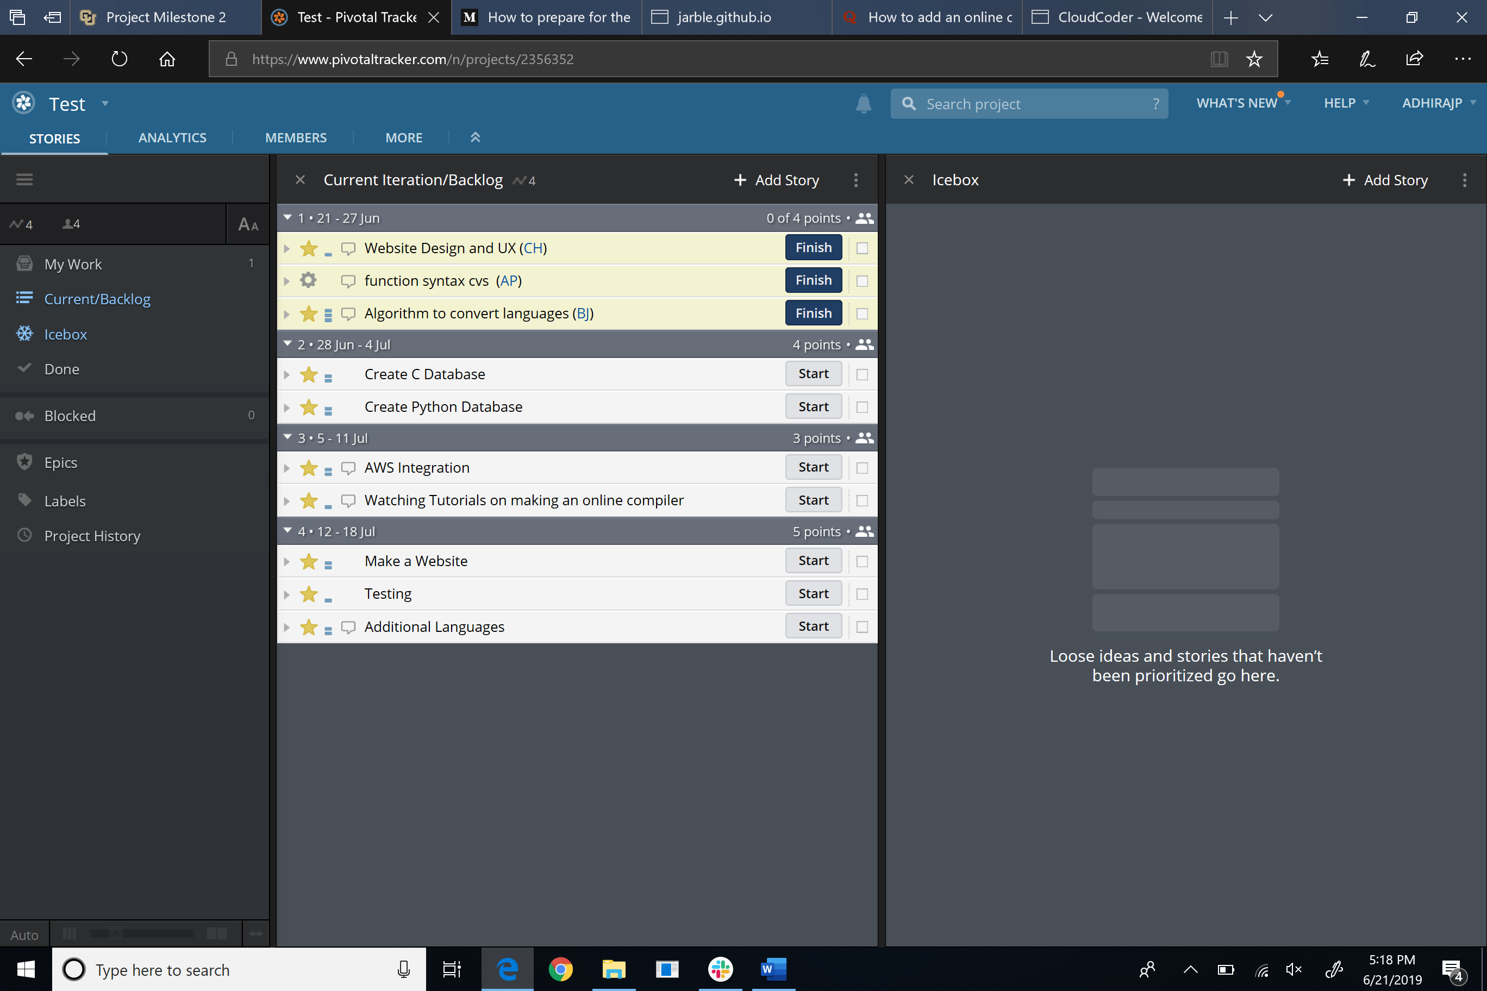

**Function Syntax Document**

This would be a reference guide that will include some basic statements such as “if-statements” and “print-statements” between the two languages. This would help us prevent having any confusion between the two language syntaxes.

**Algorithm to convert the languages**

We would be using an algorithm that detects a particular character and we would then print out the right syntax for that language.

**Website Design and UX**

We can not code the website until we know how the website would look like. We would be using Adobe Illustrator to come up with our web design rather than having a simple black and white page for the code converter

**Create C & Python Database**

We would be using MySQL Workbench to create the database and link it to the website for data storage.

**Tutorial on making an online compiler**

We would be using some online resources to understand how to implement an online compiler such as <https://www.youtube.com/watch?v=64Vb9pxXvdQ> and <https://cloudcoder.org/> .

**Make a website**

We would build a website by using HTML, CSS, and JavaScript on Brackets.

**AWS Integration**

We would use it as a virtual machine to run and compile the online code. In case of error, our computers would not be affected and only the virtual environment would be affected.

**Prototyping**

We will be creating a layout of how the final project would look like and have a reference when creating the HTML and CSS. We would also optimize usability.

**Test**

We conduct multiple test on our website to check for any bugs and sort it out.

**Additional Languages**

Once we successfully implement the conversion between the two languages, we would then push our limits to other programming languages such as Java, C++, etc.